Nick Loder

CS-210 Project Three Documentation

6/28/24

When opening the program, you are greeted with a menu screen which explains what inputs you can put into the program and what each of these do.

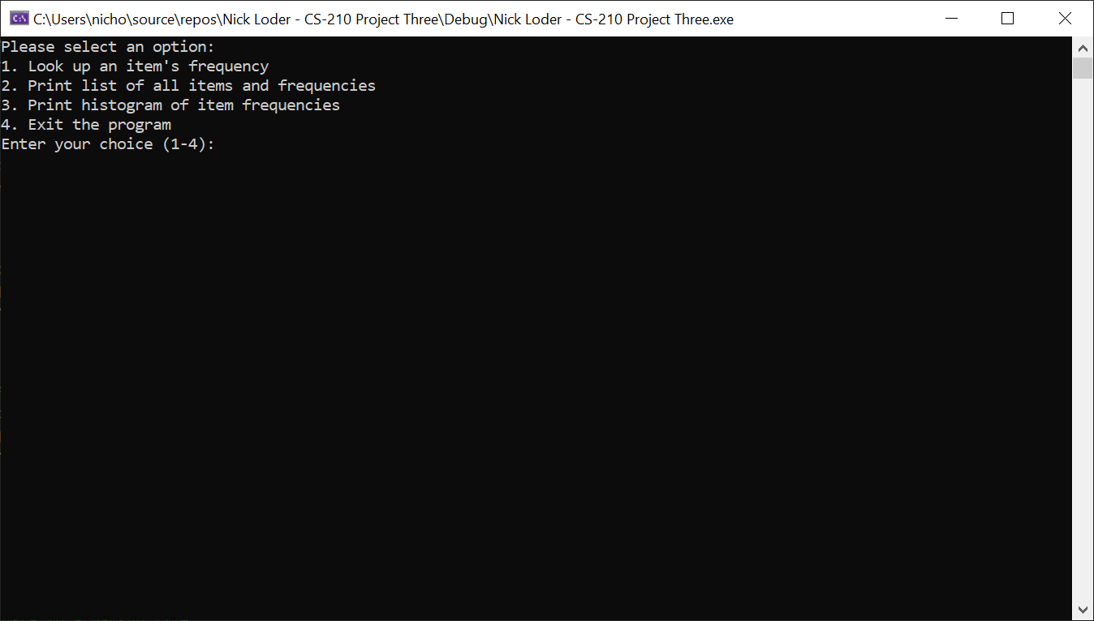

Inputting 1 into the user input gives you another input to enter the item that you wish to look up.

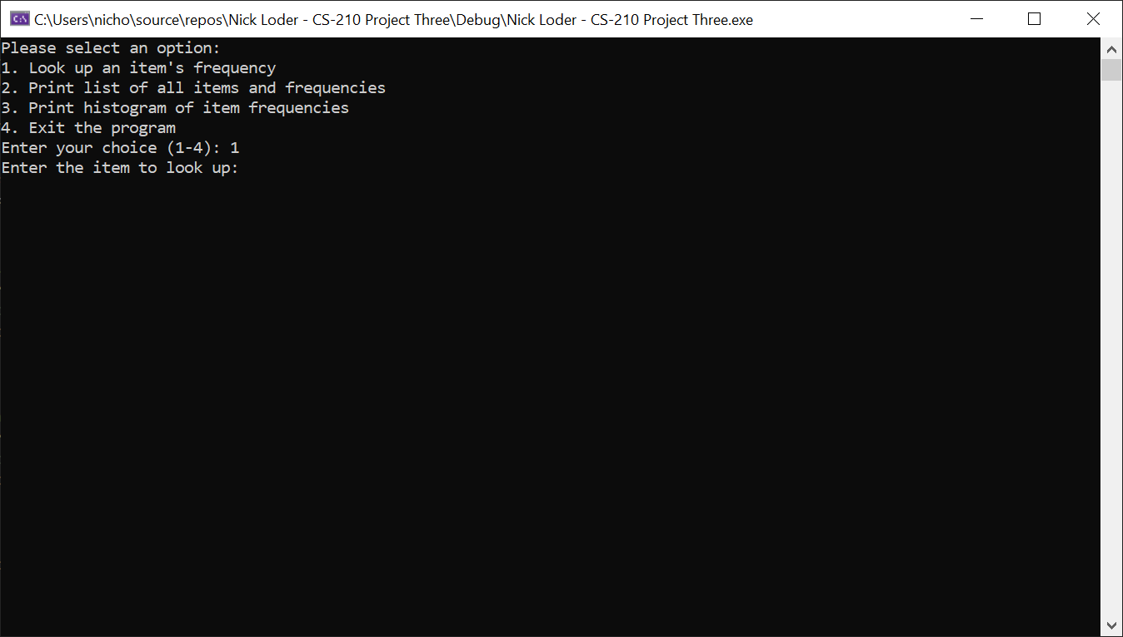

If you input an item that is on the input file, the program will print out for you the frequency of said item on said input file, then print out the menu again so you can input in another option.

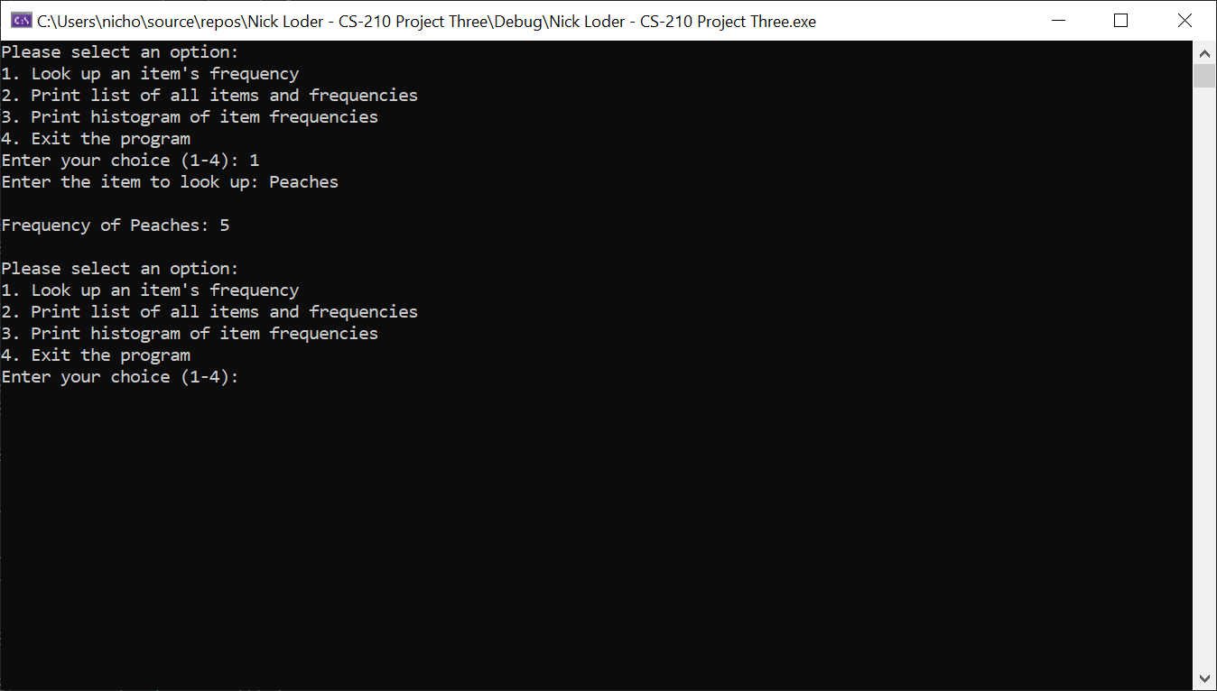

If you input an item that is not on the input file (for example if you misspell an item that is on the input file), the program will return 0 as the frequency of the incorrectly inputted item and print out the menu again so you can input in another option.

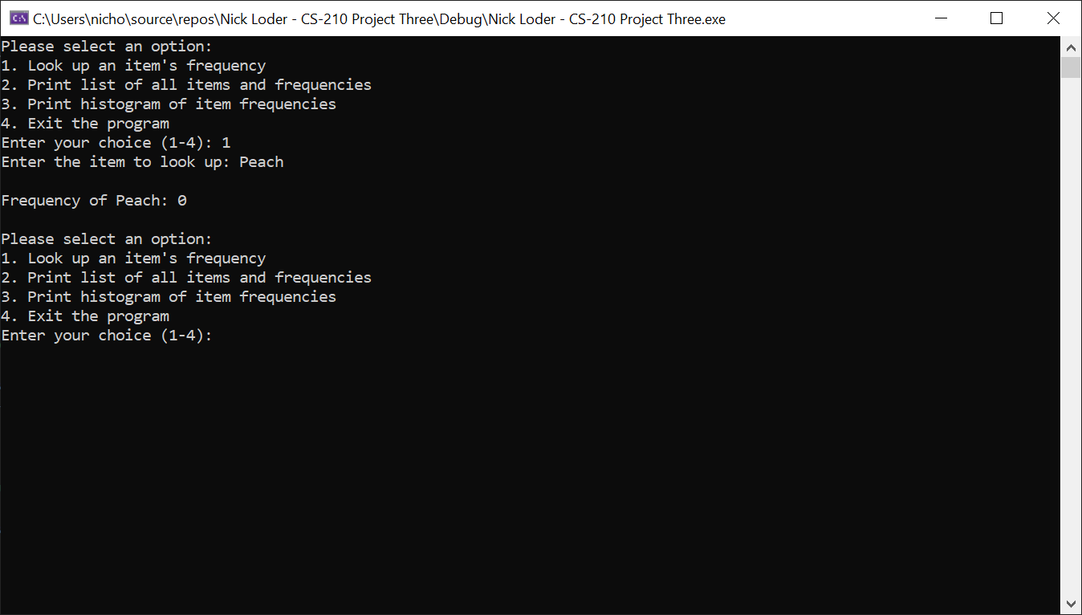

Inputting 2 into the user input prints out a list of every item in the input file and the frequency in which they appear, then prints out the menu again so you can input in another option.

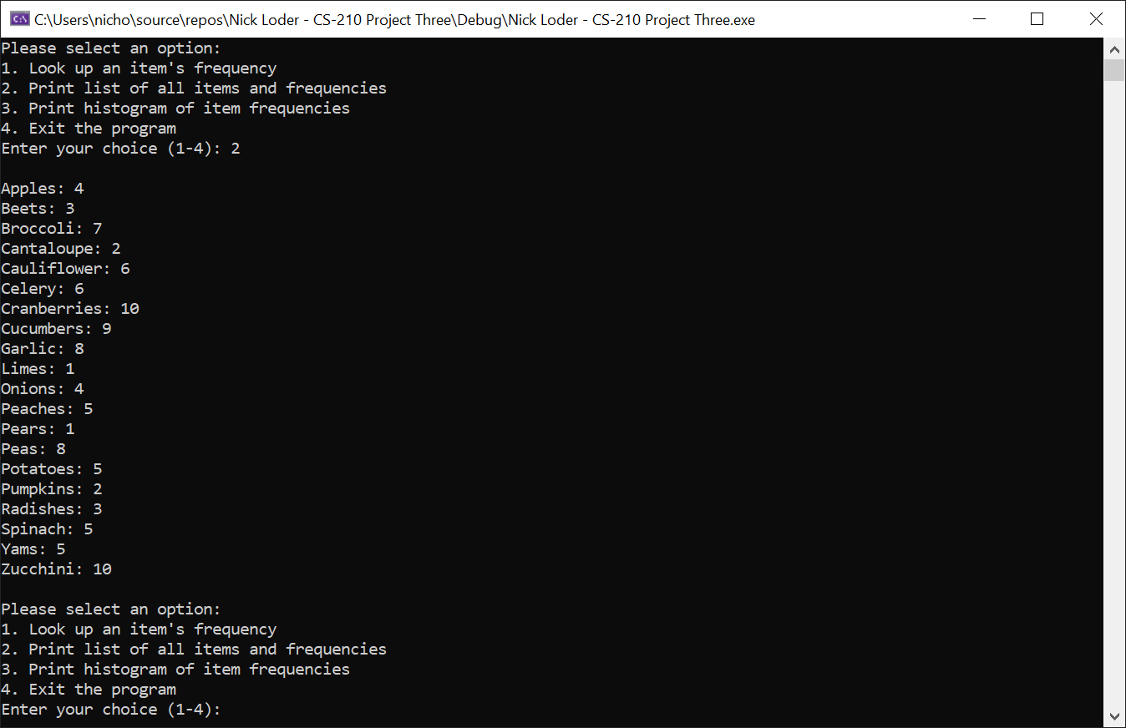

Inputting 3 into the user input prints out a histogram of every item in the input file and the frequency in which they appear, then prints out the menu again so you can input in another option.

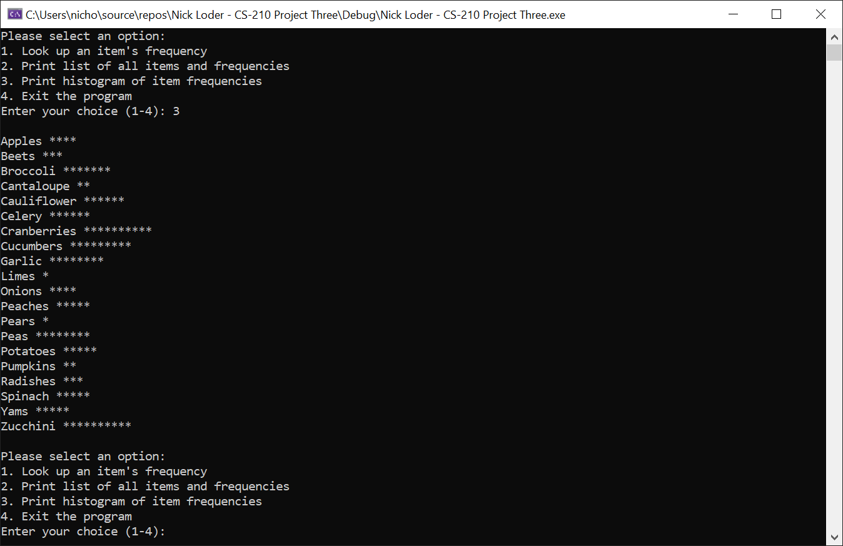

Inputting 4 into the user input exits the program.

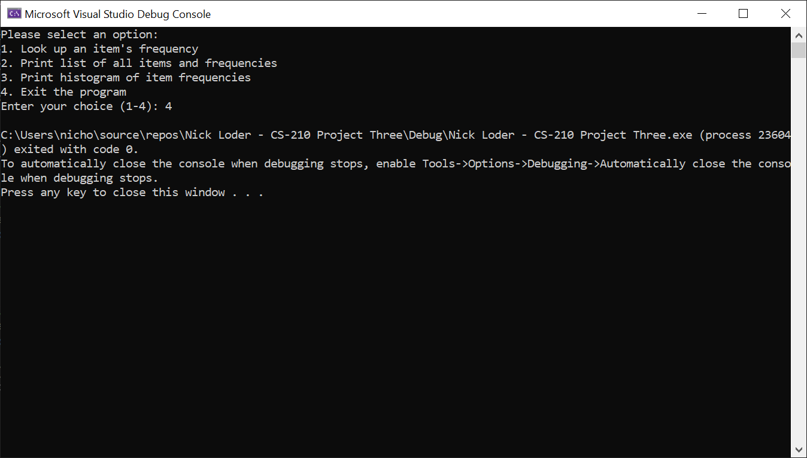

Inputting anything that is not a number between 1 to 4 prints out an error message stating that you have entered an invalid choice, then prints out another menu screen so you can try inputting in an option again.

